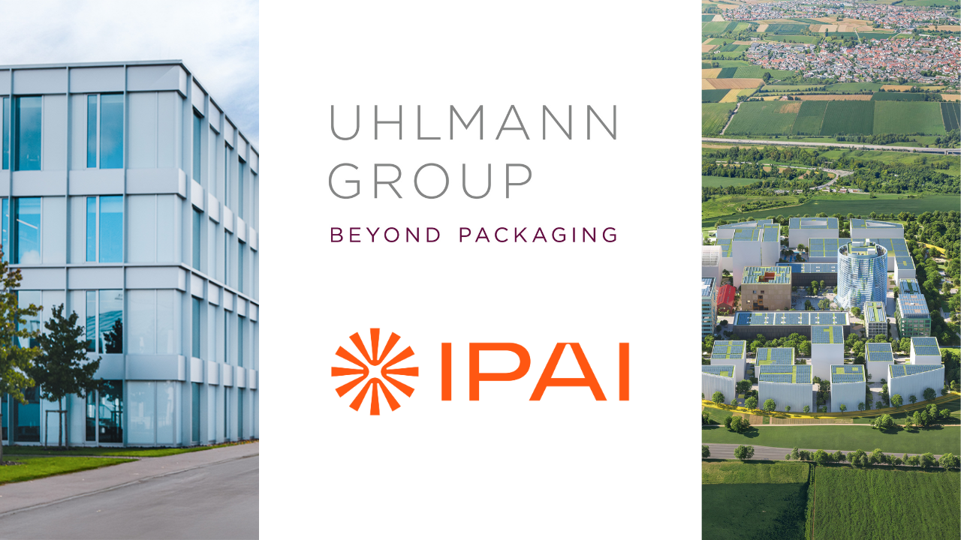Uhlmann Group joins Europe's leading AI innovation platform IPAI
Packaging machinery group contributes industrial AI expertise and a mid-sized business perspective to a leading AI network

Laupheim, September 28, 2026. Uhlmann Group is joining the Innovation Park Artificial Intelligence (IPAI) in Heilbronn. By becoming a member, the internationally active packaging machinery group is consistently advancing its AI strategy.

Artificial intelligence is a key enabler for Uhlmann Group to connect data-driven solutions with its machinery business, increase productivity and innovation speed, and drive sustainable growth. For operators of industrial production and packaging lines, this translates into tangible benefits such as higher machine availability, faster commissioning, more stable processes, and more efficient use of machine and process data. In addition, AI is a decisive factor for the competitiveness and future viability of European mechanical engineering and the packaging machinery industry. Through its engagement, Uhlmann Group contributes extensive practical expertise and proven AI applications already successfully deployed in industrial manufacturing environments to the network.

Prof. Matthias Niemeyer, CEO of Uhlmann Group, explains: “Industrial AI is a team sport. As a member of IPAI, we become part of a strong network of researchers, start-ups and technology partners. Together, we are building a European AI and robotics hub that combines technological competitiveness with European values. Within IPAI, we are jointly laying the foundations for European AI and data sovereignty.”

The Uhlmann Group will contribute practical industrial AI experience from the mid-sized manufacturing sector. Having already achieved a high level of maturity in implementing and scaling AI, the Group plans to share proven methodologies and successfully deployed AI solutions, including Uhlmann SmartAssist. This AI-based system supports employees at Group Company Uhlmann Pac-Systeme in setting up complex, customer-specific packaging machines.

Moritz Gräter, CEO of IPAI, comments: “The addition of Uhlmann Group sends a strong signal for the transformation of the mechanical engineering industry. The Group brings valuable practical experience from the mid-sized industrial sector as well as proven AI applications such as SmartAssist to our platform. Together, we are bridging the gap between innovative technology and practical implementation in industry.”

Pioneering digitalization and innovative AI projects

Today, Uhlmann Group is already driving data-driven value creation, AI-supported automation and intelligent production systems within the industrial mid-sized sector. Examples include Uhlmann Pac-Systeme’s software platform Pexcite, KOCH’s smartpacks, the Group’s involvement in the Factory-X initiative, and PacXplorer, an AI demonstrator and development platform jointly developed with SAP.

In the development and use of AI-based applications and services, the Group follows a two-dimensional approach. On the one hand, employees across the organization are empowered and encouraged to use AI tools in their daily work (“Wide”). On the other hand, engineers and developers are working to deeply integrate AI into products and processes (“Deep”).

Through its collaboration within IPAI, Uhlmann Group aims in particular to develop, test and more rapidly scale industrial AI solutions together with partners for use in production and service environments. In doing so, the Group supports its strategic objective of further complementing its traditional machinery business with data-driven solutions and digital services while unlocking additional growth opportunities. In addition, the network is expected to provide valuable impulses for the development of sovereign AI and data solutions, the protection of industrial know-how, and the advancement of technologies for intelligent automation and manufacturing. Furthermore, IPAI is expected to help accelerate and scale the integration of AI applications into seamless end-to-end processes across the entire value chain.

ABOUT IPAI
IPAI enables organizations to advance their AI transformation through a collaborative, hands-on and holistic approach. Its vision is to establish an application-centered AI innovation and collaboration platform based on European values. Together with its members and partners from business, government and society, IPAI is creating the “Global Home of Human AI” in Heilbronn, a central hub for the future of European AI.

As a central point of contact, IPAI bridges the gap between cutting-edge research and practical application by creating an open ecosystem with a broad range of services tailored to the needs of companies and institutions. This ecosystem supports the collaborative development of innovative and responsible AI solutions.

At the heart of this vision is the IPAI CAMPUS. Situated on a 30-hectare site in northern Heilbronn, the campus will provide the infrastructure required for a distinctly European approach to AI. Construction began in late 2025, and the campus, which will eventually accommodate 5,000 people working in the field of AI, is expected to see its first buildings completed by the end of 2027.

The initiators of the IPAI platform include the State of Baden-Württemberg, the Dieter Schwarz Foundation, Schwarz Group companies and the City of Heilbronn.

ABOUT THE UHLMANN GROUP
Uhlmann Group consists of six Group Companies and their respective subsidiaries: Uhlmann Pac-Systeme (Laupheim, Germany), KOCH Pac-Systeme (Pfalzgrafenweiler, Germany), Cremer Speciaalmachines (Lisse, Netherlands), Wonder Packing (Jinzhou, China), Goldfuss Automation (Balingen, Germany) and Axito (Wrocław, Poland). Together, they are committed to ensuring the global availability of sensitive products in the pharmaceutical, healthcare, consumer goods, food and agricultural industries. Through a comprehensive and innovative portfolio of machines, software and services, the companies cover the entire packaging value chain. Under the leadership of Uhlmann Group Holding, the Group is driving the transformation of the packaging ecosystem with a strong focus on digitalization and sustainability. Around 2,500 people work for the Group at 22 locations worldwide. In fiscal year 2025/26, Group revenue amounted to €538 million.

More information: www.uhlmann-group.com

Media Contact
Meike Grisson
thepublic GmbH
Phone: +49 151 14648060
m.grisson@thepublicpr.com

